**B_18_DAYAL ADITYA KISHOR**

**Assignment No. 7**

**Title:**

Study and Implementation of

* Sub queries(nested queries)
* Views

**Problem Statement:**

Employee (employee-name, street, city)

Works (employee-name, company-name, salary)

Company (company-name, city)

Managers (employee-name, manager-name)

Insert appropriate data in the tables.

**Queries:**

Solve Query 1 to 4 using appropriate operation in, not in, all, some, exists etc

1. Find the names, street address, and cities of residence of all employees who work for Tata and earn more than $10,000
2. Find all employees in the database who do not work for Tata
3. Find all employees in the database who earn more than every employee of Reliance
4. Find the company that has the smallest payroll
5. Create a view for names and cities of residence of all employees who work for First Bank Corporation

**Answers:**

Create a Table employee:

create table employee(employee_name varchar(20) primary key ,street varchar(20), city varchar(20));

Create a Table company:

create table company(company_name varchar(50) primary key, city varchar(20));

Create a Table works:

create table works(employee_name varchar(20), company_name varchar(50), salary decimal(10,2),primary key(employee_name,company_name), foreign key(employee_name) references employee(employee_name), foreign key(company_name) references company(company_name));

Create a Table managers:

create table manages(employee_name varchar(20), manager_name varchar(20), primary key(manager_name));

Insert Values

insert into employee values('Dustin','Bel Road','Delhi');

insert into employee values('Riya','Bel Road','Delhi');

insert into employee values('Rakul','Chruch Road','Mumbai');

insert into employee values('Bob','MG Road','Hyderabad');

insert into employee values('Ayan','Commercial street','Surat');

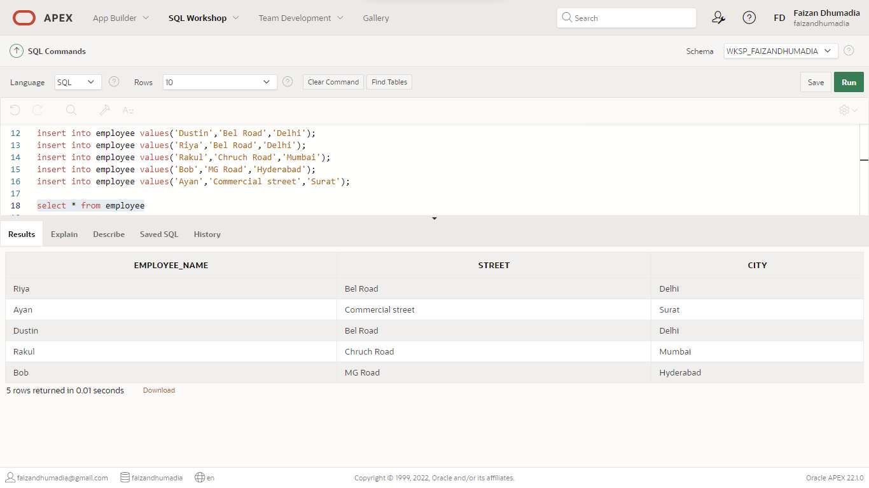

insert into company values('First Bank Corporation','Delhi');

insert into company values('Tata','Hyderabad');

insert into company values('Adobe','Mysore');

insert into company values('Reliance','Surat');

insert into company values('Oracle','Mumbai');

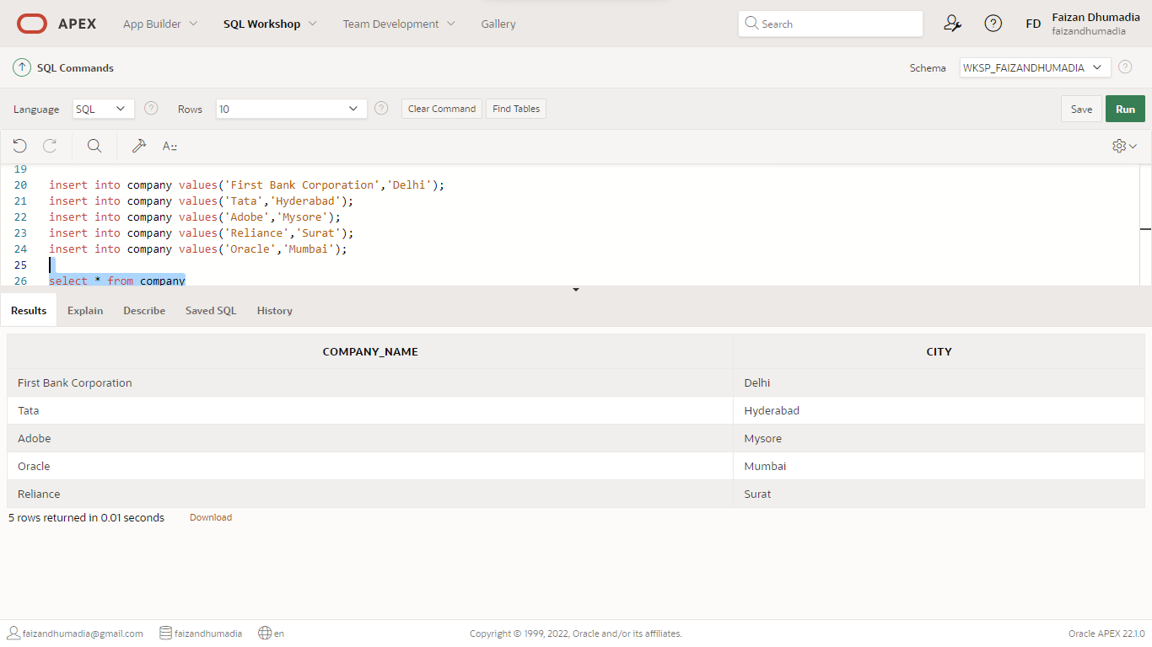

insert into works values('Dustin', 'First Bank Corporation', 21000);

insert into works values('Bob', 'Tata', 40000);

insert into works values('Riya', 'Reliance', 17000);

insert into works values('Rakul', 'First Bank Corporation', 12000);

insert into works values('Ayan', 'Reliance', 15000);

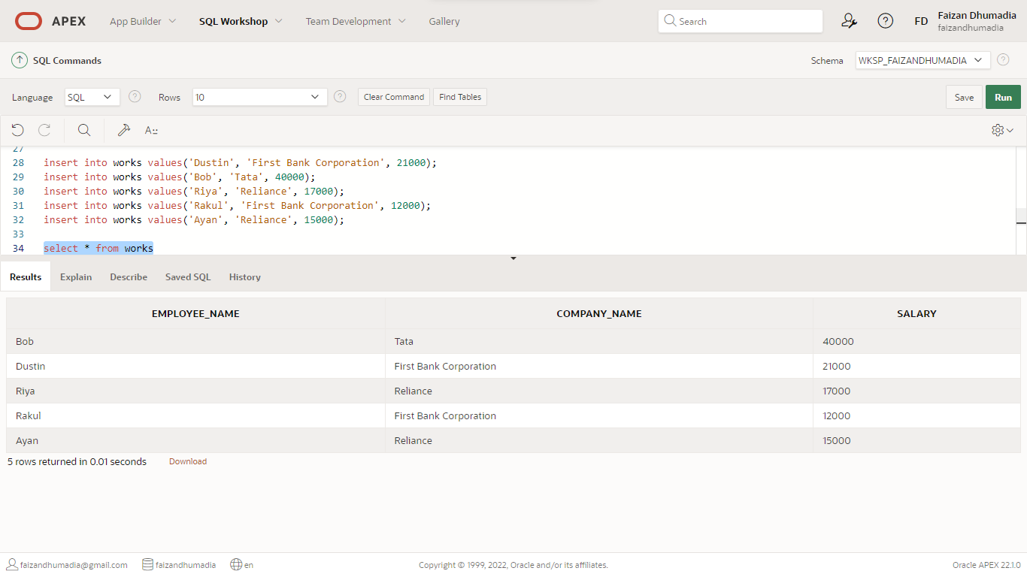

insert into manages values('Dustin','Saloni');

insert into manages values ('Bob','Nayan');

insert into manages values('Riya','Dustin');

insert into manages values('Rakul','Somani');

insert into manages values('Ayan','Sharon');

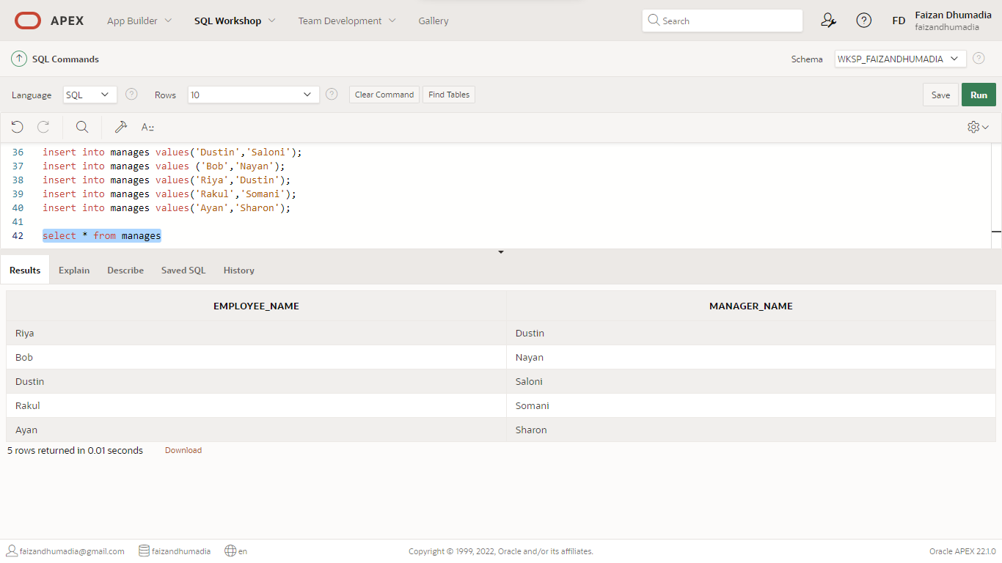

1. Find the names, street address, and cities of residence of all employees who work for Tata and earn more than $10,000

select e.employee_name,e.street,e.city from employee e, works w where w.company_name = 'Tata' and w.salary > 10000 and e.employee_name = w.employee_name;

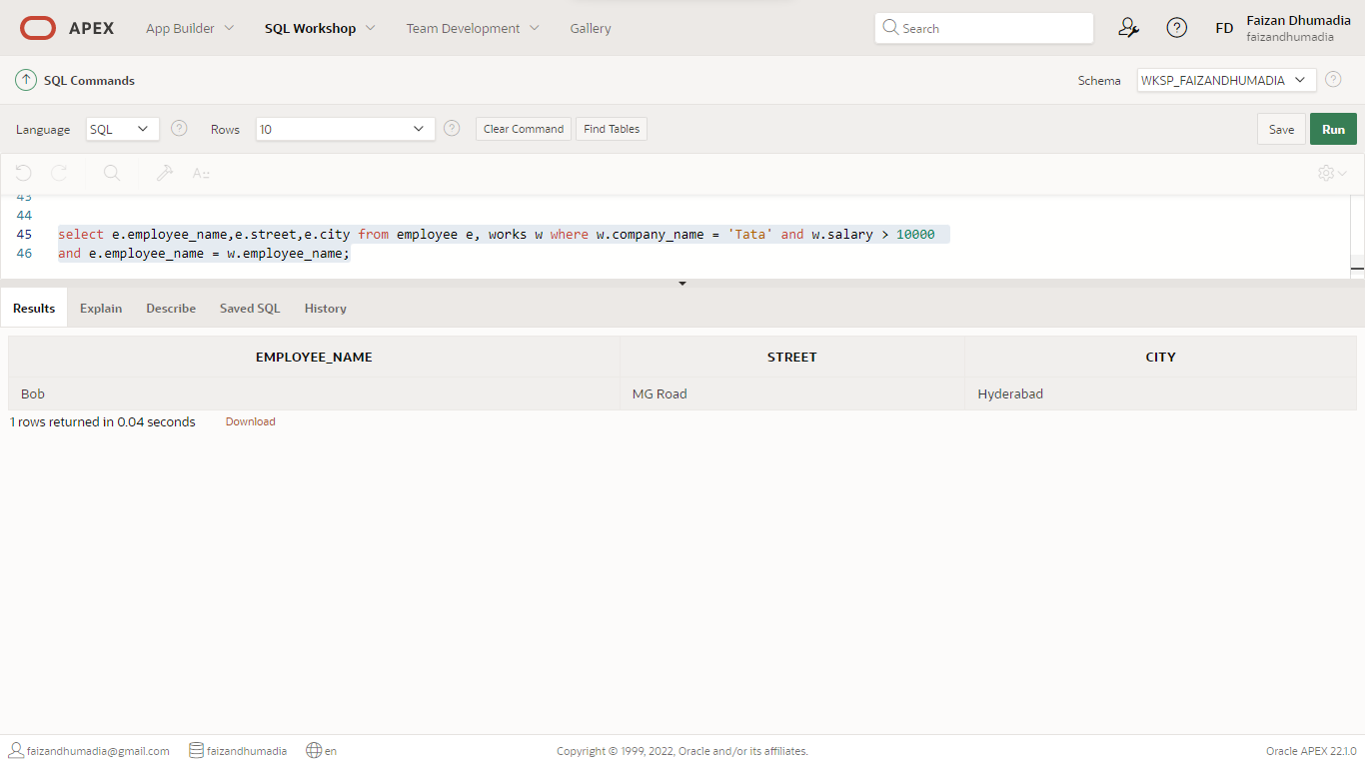

2. Find all employees in the database who do not work for Tata

select e.employee_name, w.company_name from employee e, works w where e.employee_name = w.employee_name and w.company_name <> 'Tata';

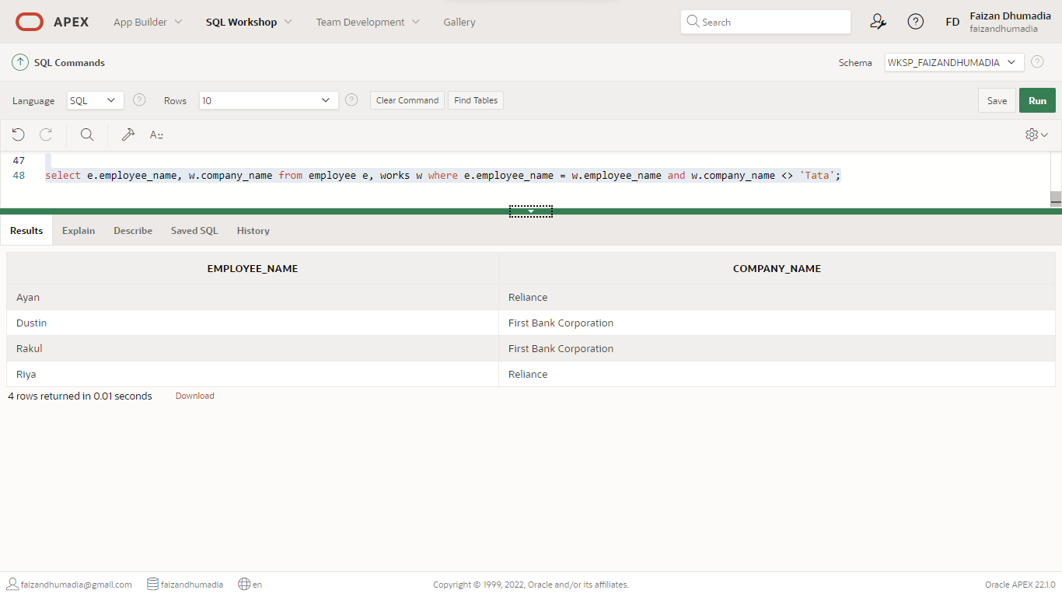

3. Find all employees in the database who earn more than every employee of Reliance

select e.employee_name, w.company_name from employee e, works w where e.employee_name = w.employee_name and w.salary>all(select w.salary from works w where w.company_name = 'Reliance');

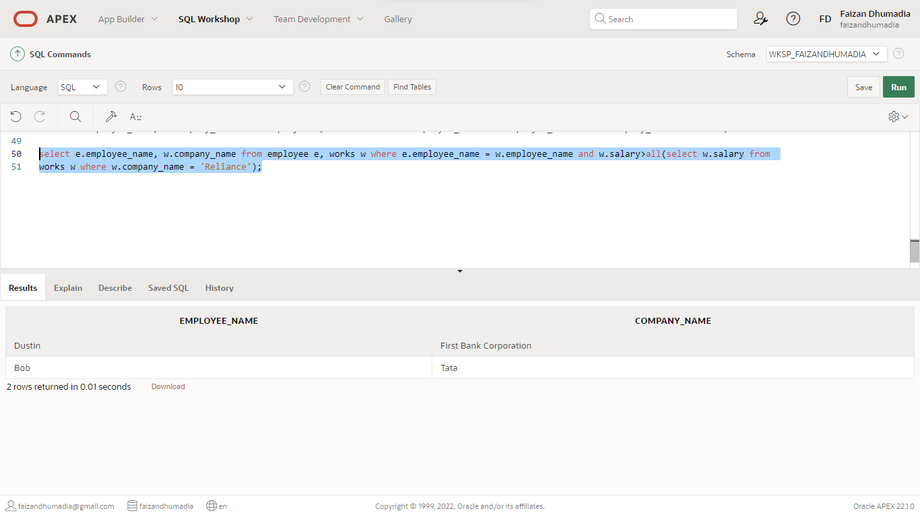

4. Find the company that has the smallest payroll

select company_name, sum(salary) from works group by company_name having sum (salary) <= all (select sum (salary) from works group by company_name)

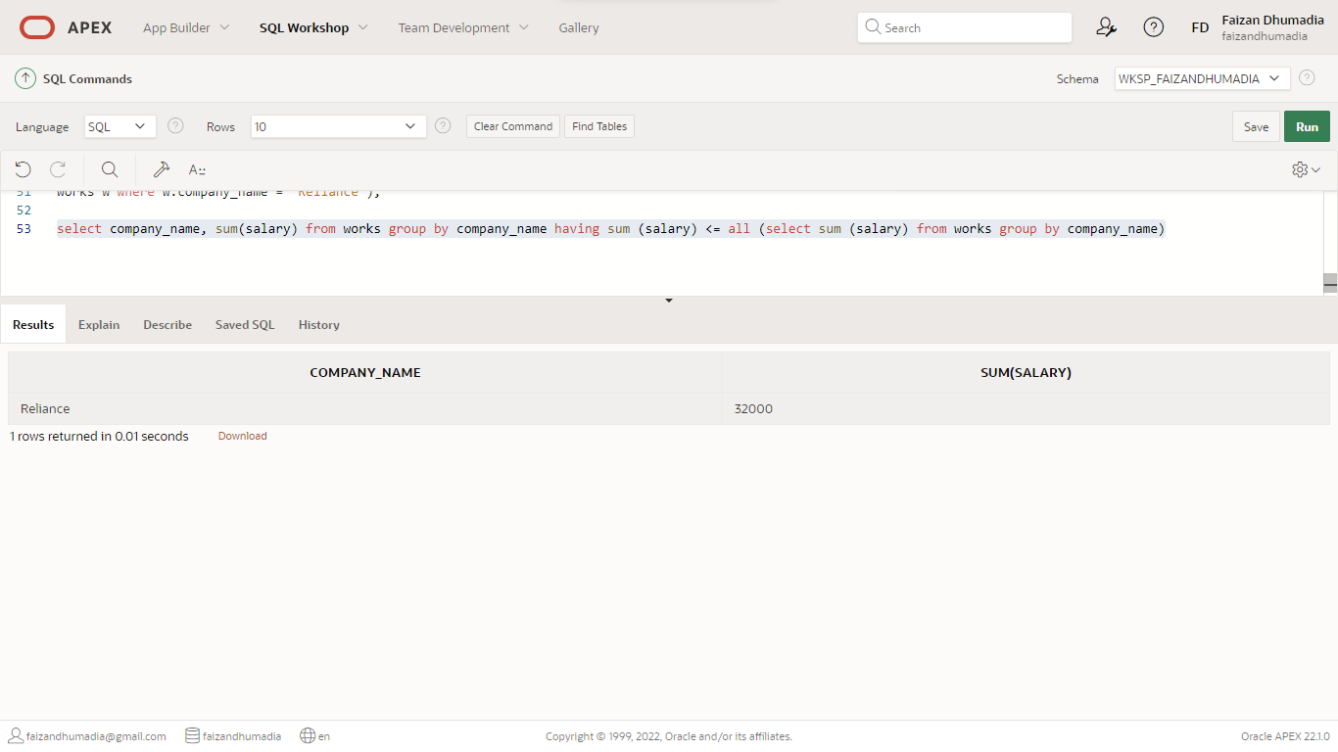

5. Create a view for names and cities of residence of all employees who work for First Bank Corporation

create view FBCview as select e.employee_name,e.city from employee e, works w where w.company_name = 'First Bank Corporation' and e.employee_name = w.employee_name;

select * from FBCview

